Trees

What is a Tree?

- A tree is a widely used abstract data type that simulates a hierarchical tree structure, with a root value and sub-trees of children with a parent node, represented as a set of linked nodes.

Let's Take an example to understand the structure of a Tree.
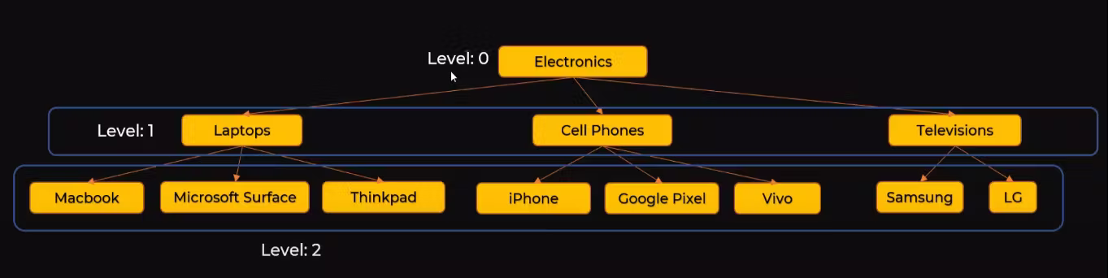
- You must have seen this type of implementation on any of the e-commerce websites that you visit. There will be a Main Category (Electronics), then it might be linked to different Sub Categories(Such as - Laptop, cellphones) and then the final Products(such as MacBook, iPhone etc)
- Now to represent this we can't use Linear Data Structures such as --> Array, Linked List, Stacks or Queues. So we need a hierarchical representation for this hence we will use Tree. There could be different Levels to a single Tree.

General Tree
- Root Node --> A root node is either the topmost or the bottom node in a tree data structure, depending on how the tree is represented visually.

- Node --> A tree is a collection of entities called nodes.
  - Nodes are connected by edges.
  - Each node contains a value or data, and it may or may not have a child node.
- Parent and Children
  - Child is a node that has a parent node.
  - The parent is a node that has an edge over a child node.
  - The leaf is a node that does not have a child node in the tree.
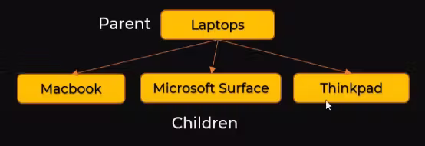

Check the Implementation of the General Tree - > general_tree.py

Exercise 1) Below is the management hierarchy of a company.
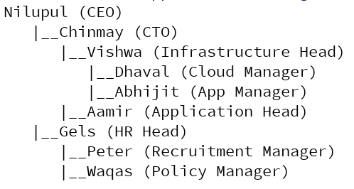
Extent tree class we built so that it takes name and designation in data part of TreeNode class. Now extend print_tree function such that it can print either name tree, designation tree or name and designation tree. As shown below,
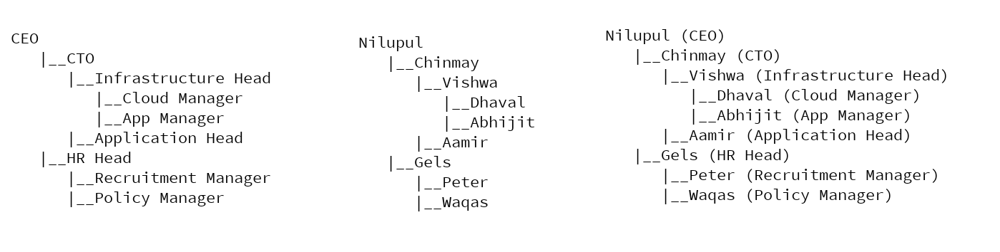
Here is how your main function should will look like,

if __name__ == '__main__':
root_node = build_management_tree()
root_node.print_tree("name") # prints only name hierarchy
root_node.print_tree("designation") # prints only designation hierarchy
root_node.print_tree("both") # prints both (name and designation) hierarchy

Exercise 2) - Modify print_tree method to take tree level as input. And that should print tree only up to that level.

Binary Tree

What problem does Binary Tree solve?
- In many different programming we have a thing called Sets.
  - Sets are used to store multiple items in a single variable.
  - Set is one of 4 built-in data types in Python used to store collections of data, the other 3 are List, Tuple, and Dictionary, all with different qualities and usage.
- Sets are more like Lists but there is a difference when we insert an element in a set it will make sure that those elements are unique to the set, unlike a list where duplicates can be present.
- Internally to implement set, one of the ways is using the Binary Search Tree.

What is Binary Tree?
- A binary tree is a tree data structure in which each node has at most two children, which are referred to as
  - the left child
  - the right child.
- A Binary Search Tree it is a special case of Binary Tree where the elements have some kind of order in them. We can also say that it is an ordered or sorted Binary tree
  - It is a rooted binary tree whose internal nodes each store a key greater than all the keys in the node's left sub-tree and less than those in its right sub-tree.

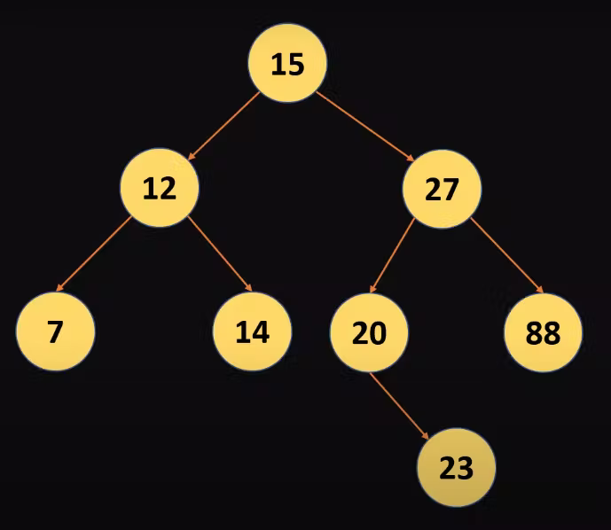

Searching in Binary Search Tree
- In the diagram above we can see that all the values less than the root node are placed on the left side of it and the greater ones are on the right side of the root node which is 15.

- Assume we want to search 14 in the above Binary Search Tree
  - Then first we will compare the root that is 15 so since 15 is greater than 14 so if 14 resides in the Tree hence it should be on the left side.
  - When we search then we find 12 not 14 is greater than 12 hence it should be on the right side of the sub-tree.
- Below is a visual representation of how we just searched 14 in a binary search tree.
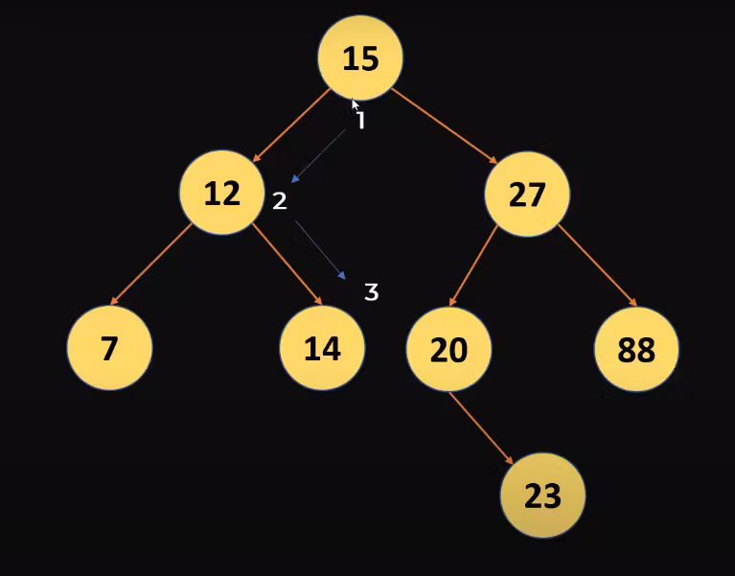

Search Complexity
Since we reduced the space by 1/2 by every iteration.
- n = 8
- 8->4->2->1
- if there are 8 elements hence we got 3 iteration
- log8 = 3
- Search Complexity = O(log n)

Inserting in Binary Search Tree
- Let's assume we want to insert element 13 in the same binary search tree.
- We will first compare it with 15 since 13 is less than 15 hence it will go to the left side of the root 15 node.
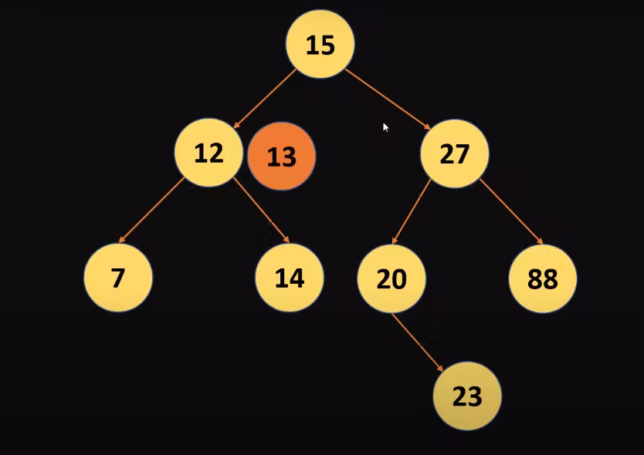
- Now you realize that 13 is greater than the current 12 hence it will go to the right sub-tree of 12.
- We have 14 here and 13 is less than 14 hence it will go to the left sub-tree of 14.
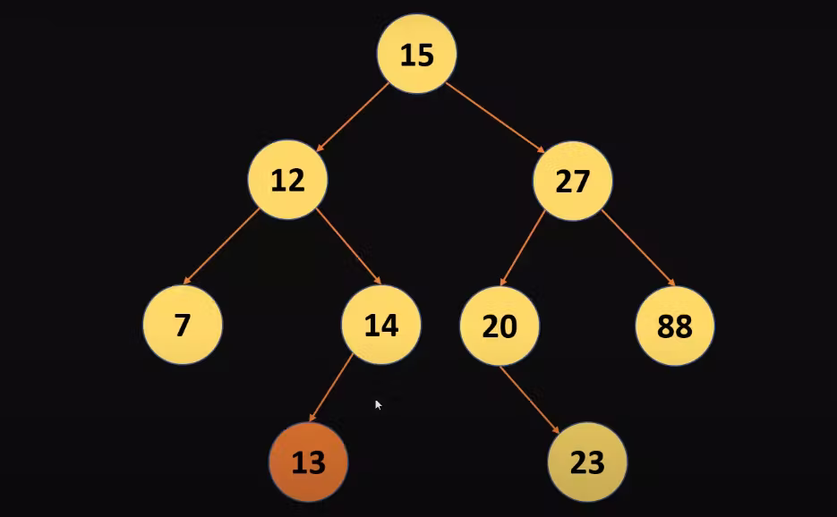

Breadth First Search (BFS) and Depth First Search(DFS)
- Any process for visiting all of the nodes in some order is called a traversal.
- There are two technique for this: BFS and DFS

BFS
- BFS stands for Breadth-First Search is a vertex-based technique for finding the shortest path in the graph. It uses a Queue data structure which follows first in first out. In BFS, one vertex is selected at a time when it is visited and marked then its adjacent are visited and stored in the queue. It is slower than DFS if we take the below example.
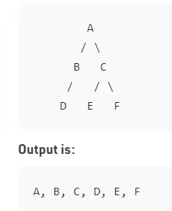

DFS
- DFS stands for Depth First Search is an edge-based technique. It uses the Stack data structure, performs two stages, first visited vertices are pushed into the stack and second if there are no vertices then visited vertices are popped.

There are three types of traversals in DFS -
- In-order Traversal
- Traverse the left sub-tree -> Visit the root -> Traverse the right sub-tree.

- Pre-order Traversal
- Visit the root ->Traverse the left subt-ree ->Traverse the right sub-tree

- Post-order Traversal
- Traverse the left sub-tree -> Traverse the right sub-tree -> Visit the root

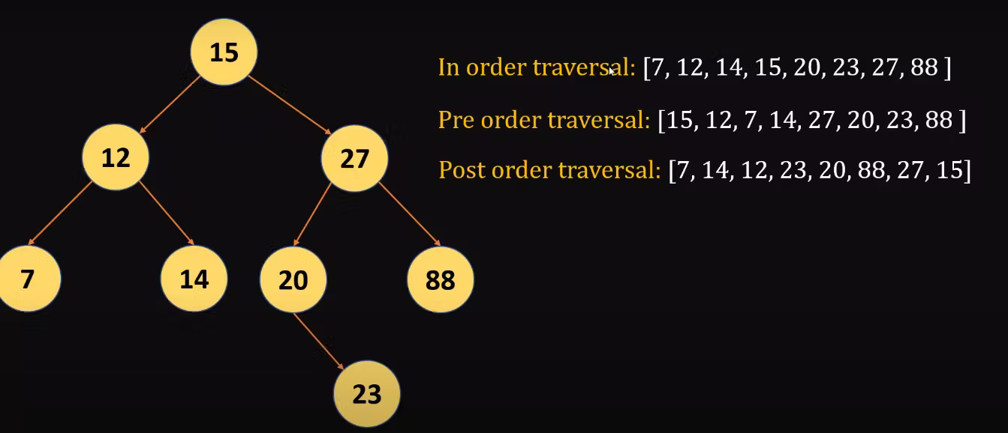

Check the implementation of the BinarySearchTree - >binary_search_tree.py

Exercises:
- post_order_traversal(): performs post-order traversal of a binary tree
- pre_order_traversal(): performs pre-order traversal of a binary tree
- find_min(): finds minimum element in entire binary tree
- find_max(): finds maximum element in entire binary tree
- calculate_sum(): calcualtes sum of all elements

Solution - > binary_search_tree.py

Node Deletion in a Binary
There are 3 scenarios which we can face while deleting a Node in a binary search tree. Lets look on those.

Deleting a node with no child
Let's Take the example of the below Tree.
You want to delete 9 which doesn't have any child node .
This is very simple because we can directly delete the node without rearranging the Tree.
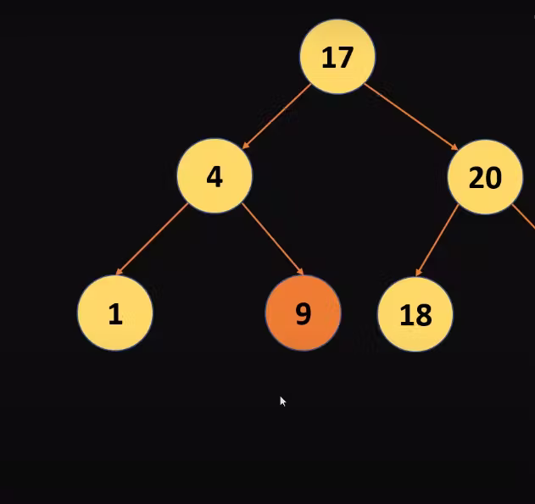

Deleting a node with one child
This is also simple, just we need to replace the child with the deleted node , as we can see in the below example we need to delete 23 so we will just replace it with 34

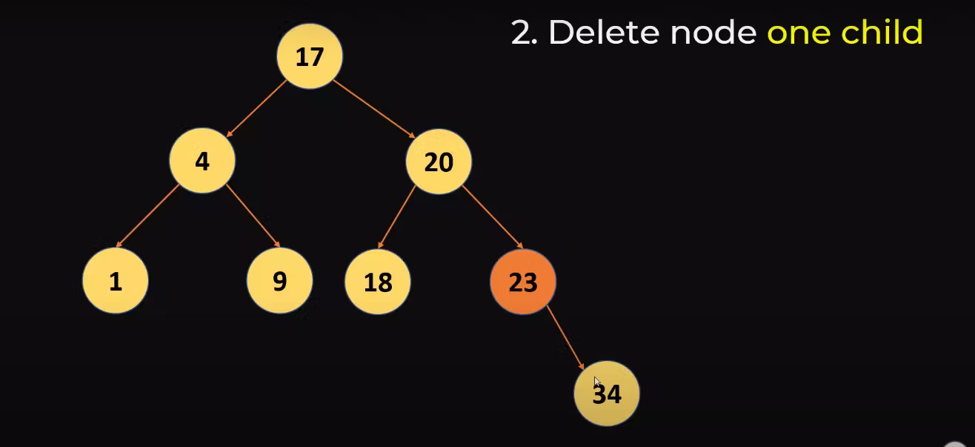
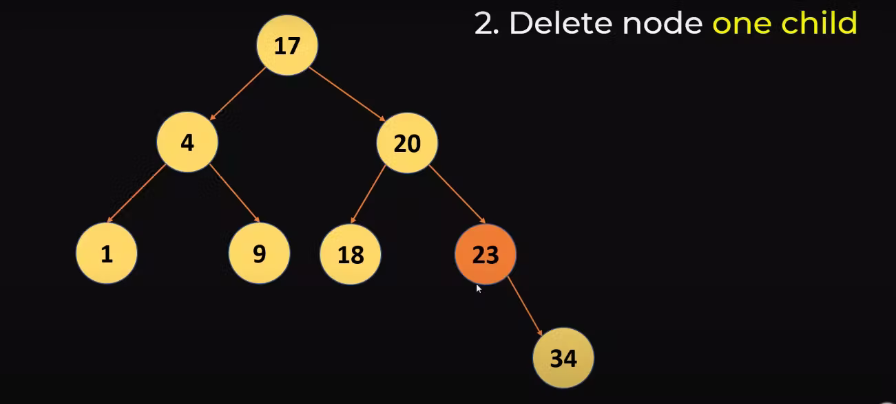

Deleting a node with two child
This one is a bit tricky because we need to delete the node and also maintain the property of Binary search tree. In the below example we are deleting 20, which has 2 child nodes
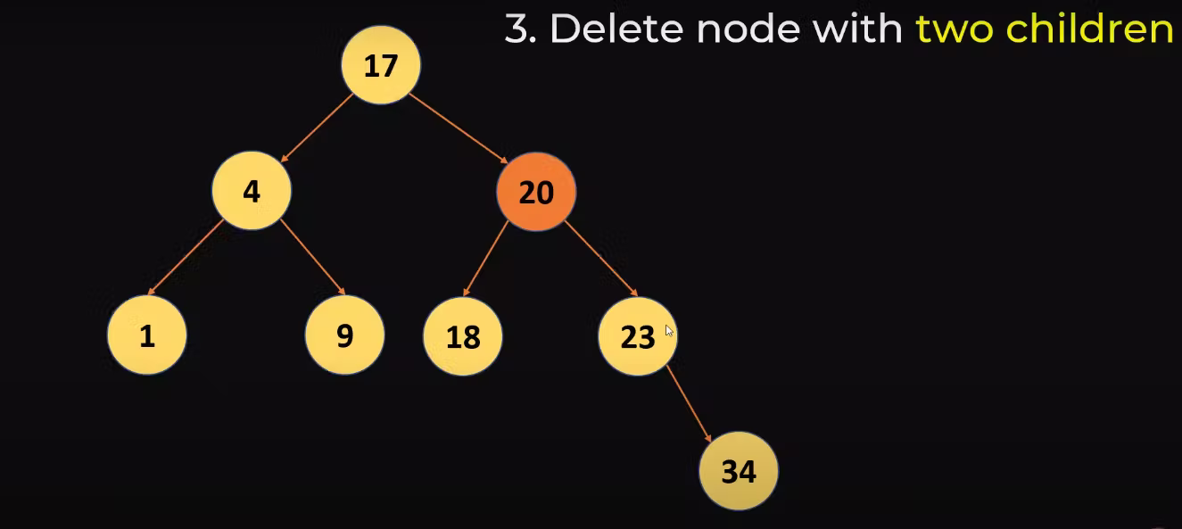
The steps to do this is:
- Copy the minimum value from the right sub-tree, hence all the values which are right will remain greater and then
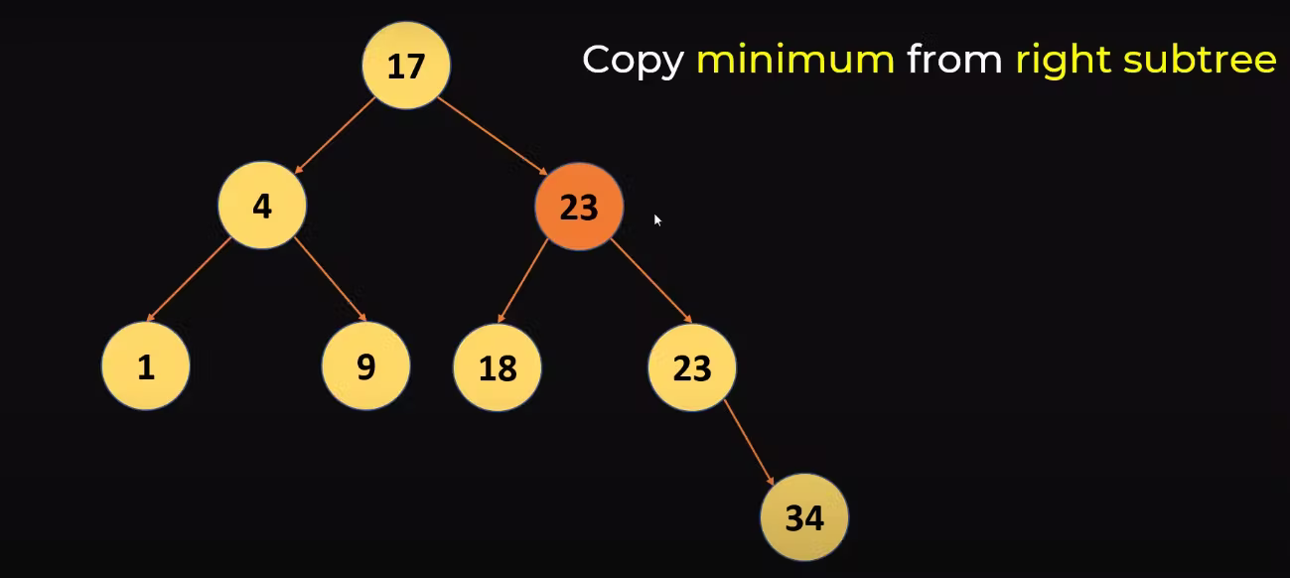

- Delete the duplicate from the right sub-tree
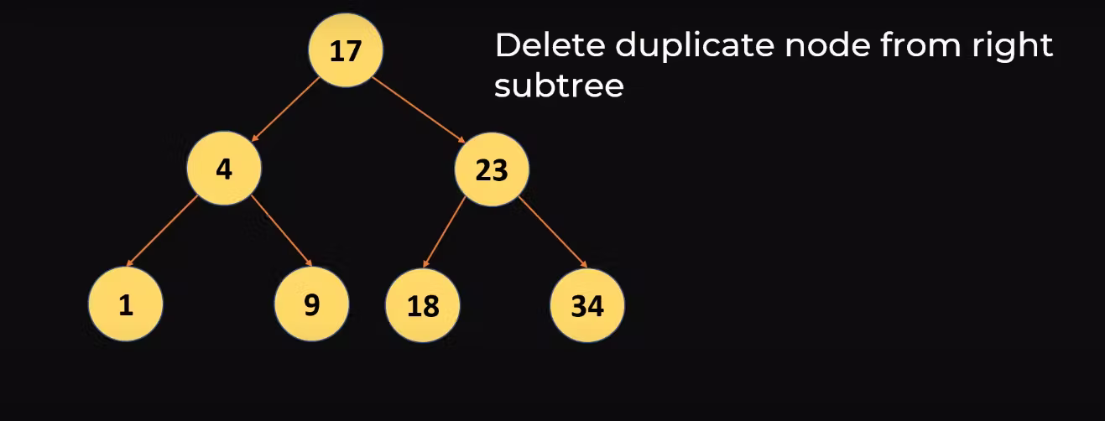
Alternate approach:
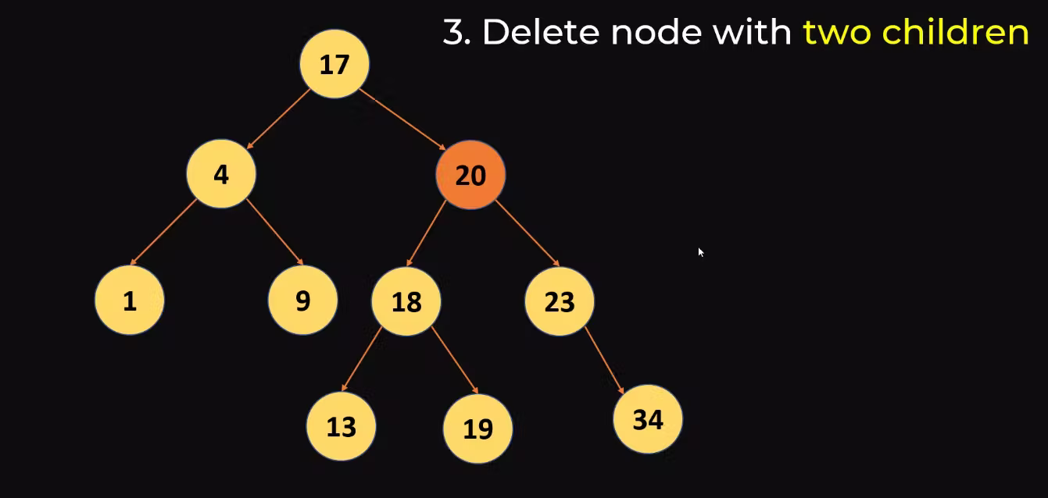
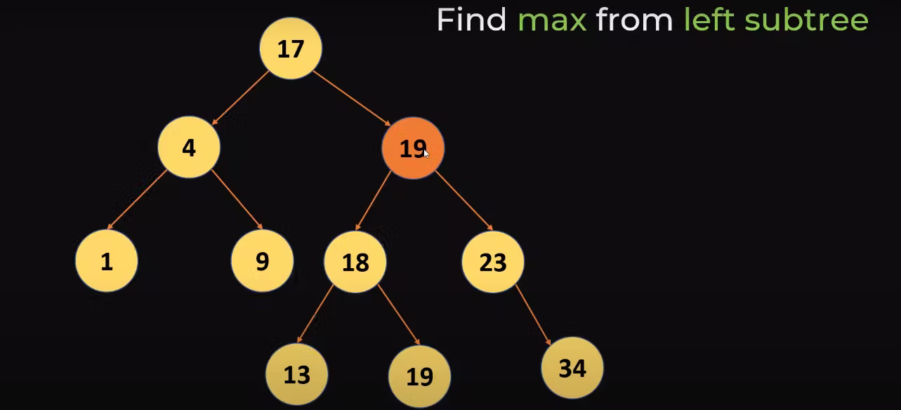
You can also look into left Sub Tree and find the maximum from there.

- copy that maximum value and then we can delete the copy, as we did below, we replaced 20 with the maximum value in the left sub-tree which is 19 and then deleted the copy of 19.
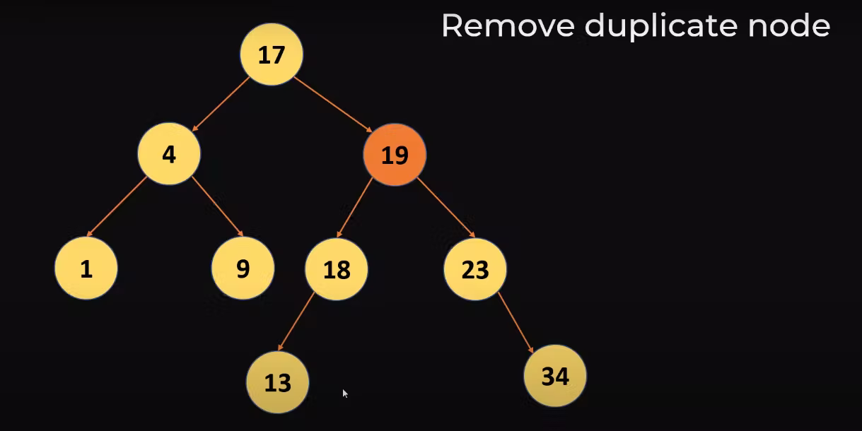

Check the implementation of the Node deletion - >binary_search_tree.py

Exercise: Modify delete method in class BinarySearchTreeNode class to use min element from left sub-tree for deletion.

